Software Requirements Specification
BE Projects 2011-12

Character Writing Robot

Team 6

Abhishek Kharche (BE-COMP)
Amarjit Prasad (BE-EXTC)
Chinmay Pednekar (BE-COMP)
Vaibhav Naidu (BE-COMP)

Table of Contents

1 Introduction 3
1.1 Definitions, Acronyms and Abbreviations 3
1.2 References 4

2 Overall Description 4

3 Details 5
3.1 Functionality 5
3.2 Supportability 6
3.3 Design Constraints 6
3.4 On-line User Documentation and Help System Requirements 7
3.5 Interfaces 8
3.5.1 User Interfaces 8
3.5.2 Hardware Interfaces 8
3.5.3 Software Interfaces 9
3.5.4 Communications Interfaces 9

4 Quality Control 10

5 Risk Management 10

Introduction

The main objective of the project is to explore the “capabilities of robotics”. One thing that a human can do better than robot is writing, so we are making a robot more like human in writing habit.
We are making a robust robotic mechanism to write characters with the help of a pen on a paper. In the project a user will select a character to be written by the robot on a window in the computer. The character information will be sent to robot by wireless communication and then the robot will move to the starting position of the character and will drop the pen. The mechanism fitted over the robot body will move in desired directions making the pen trace it and write the character. After the robot has finished writing the character it will lift the pen and move a distance from the character showing that the character is written.
The characters will be random and we are even trying to make it write a string of characters using the same algorithm.

Definitions, Acronyms and Abbreviations

Rack and Pinion: It is a mechanism used for converting circular motion into linear motion. It has a circular gear attached to the motor and a linear rob with zigzag cuts, so that both of them fin at the edges.
ZigBee module: ZigBee is a protocol that uses the 802.15.4 standard as a baseline and adds additional routing and networking functionality.
UART: It stands for Universal Asynchronous Data Receive / Transmit. It is a method of communication in which there is no need of clock for synchronization between the received and transmitted data. ZigBee uses UART for wireless communication between devices.
GUI: It stands for Graphical User Interface. It is a user interface where a user gets to see options and controls for the robot operations.
ATMEGA2560: It is a 100 pin microcontroller, having 96 I/O pins.

References

Following documents were referred for various software, hardware and algorithms used in the project:
- XBee manual IEEE® 802.15.4 OEM RF Modules by MaxStream, Inc.
- ATMEGA2560 manual for FireBird robot.
- Algorithm for character writing – Wikipedia.

Overall Description

The Robot that we are going to built will be able to write with a pen on a paper. The firebird programming board with ATMEGA2560 microcontroller controls the execution of the program. A mechanism is used to hold the pen and write on the paper. As the mechanism available (i.e. gripper) is very heavy for the firebird robot to hold, so we will make a robust robot body and a robust mechanism to move the pen in different directions.
The mechanism made will be installed on the robot body and as the mechanism moves the pen will trace it and eventually form a character. The input to the robot will be random and will be given by the user from the computer window. Now it is assumed that a user will feed only capital block of characters as the robot for now can write capital fonts only. So in whatever way the user gives the character it will be treated as a capital font only. The input character is sent to the robot using wireless communication and then executed at the robot end.
The whole robot will work in such a way that all processing part will be done by the computer terminal and the execution part will be done by the robot controller. Input character is analyzed in the computer and only the line coordinates to draw it is sent through wireless module to the robot.
The robot uses an algorithm which makes it write straight lines very precisely, but when it comes to curves it fails to draw them. So we will be varying the motor speed in such a way that it traces a curve. Although it will not be an accurate curve but the whole character can be figured out.

Details

Functionality

The functions of the various hardware and software requirement are described in the following tables:

Hardware Requirements
Sl.No | Hardware | Function | Quantity
1 | Spark Robot Programming board (ATMEGA2560) | It will be used for execution of the commands given by the user from the computer and to control various features of the robot like motion, communication, etc | 1
2 | Chassis | It will be required to give a robust body to the robot to hold the mechanism on it. | 1
3 | DC motors with position encoders and wheels | These will be required in the locomotion of the robot and also in providing strength to the robot. | 4
4 | Mini RC servo motor | It will be used in mechanism for controlled movement to write the characters. | 3
5 | Material for Rack and Pinion arrangement | It will be used for making the writing mechanism of the robot. | 4 sticks and  4 levers
6 | ZigBee module | For wireless communication between computer and robot. | 2
Software Requirements
Sl.No | Software | Function | Quantity
1 | AVR editor | For writing the embedded C codes. | 1
2 | ZigBee drivers and GUI | For sending the characters code from computer to robot. | 1
3 | Microsoft Robotics Studio | For testing the robot in the virtual environment. | 1

Supportability

For enhancing the supportability or maintainability of the project the robot body needs to be robust and so we will be making an heavy robot with chassis and four DC motors. Also the mechanism for moving the pen needs to be tuff and so we are thinking of making the rack and pinion arrangement with steel. Although the robot body will be made by steel chassis, we will be using the spark/firebird programming board for robot operations.
To enhance the possibilities of re using our project we will be making different subroutines for different characters, so that one can directly include our codes in their library for reusing it.

Design Constraints

There are many design constraints with our project as many of the components are not available in the market.
Robot body:
The Spark robot available is too light to hold the mechanism for writing character on it. So we have decided to make a robust robot body with steel chassis and four DC motors. It will make the robot body heavy and robust to hold the mechanism over it.
Writing mechanism:
The gripper available in the market is too heavy to be installed over a robot. So we have decided to design our own mechanism that will be made from rack and pinion arrangement to move the pen in different directions. The mechanism has to be stable once on the robot body and so will be given many supports (caster wheels).

Algorithm for writing character:
There are three algorithms available for writing characters:
- Starburst method.
- Bitmap method.
- Stroke method.
The algorithm we chose for writing character is STROKE method. It uses strokes of straight line to write a character. But there is a limitation of drawing curves in this method, so we will be modifying the algorithm to make it draw curve with the help of controlled motion of motors.

On-line User Documentation and Help System Requirements

The GUI for the robot at the computer terminal will have tutorials for each option available for the robot, so that a user can easily give input to the robot and use it comfortably.
A user can also refer to the uploaded manuals of the robot specifying its controls and its specifications before using it practically.
The following flow chart of the execution procedure for the case when input from the user is taken one after other will help a user know more about the functioning process of the robot:

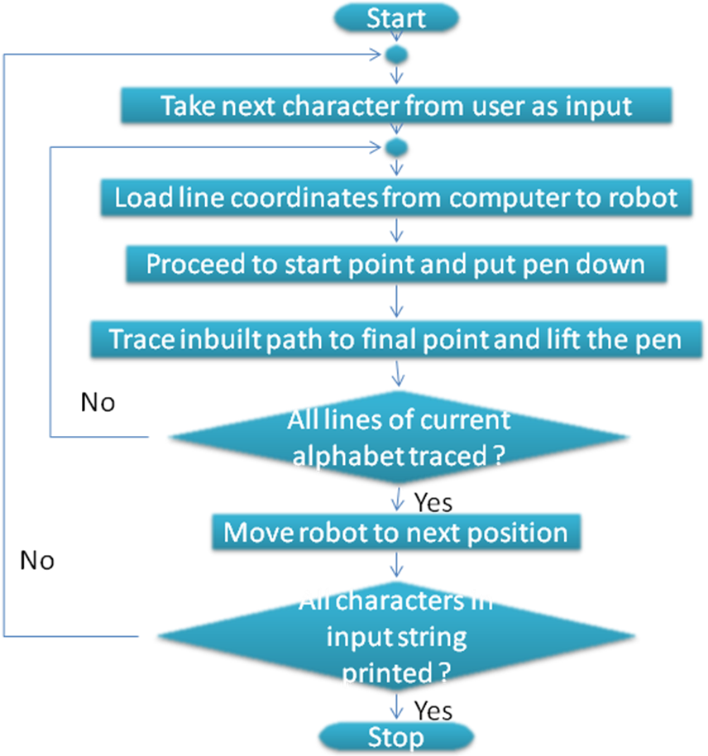

Interfaces

Our project will have a user interface GUI for users to select a desired character to be written by the robot.
It also has an arrangement made by rack and pinion setup for the pen to move in different directions and write the characters. The arrangement holds three servo motors and one pen in the centre to write on a paper.
Our project uses ZigBee module for communication between computer and the robot. There are two modules, one on the robot and other plugged into the computer. ZigBee is a protocol that uses the 802.15.4 standard as a baseline and adds additional routing and networking functionality.

User Interfaces
A user interface GUI will be made for the user to input the character in the computer. The interface will be made from visual basics having following options:
- Select the size of the font.
- Option to select a character to be written.
- Box to type the character to be written.

Hardware Interfaces

We will be designing our own mechanism using rack and pinion arrangement for moving the pen in atleast four directions.
There will be two servo motors attached with the rack and pinion arrangement for converting circular motion into linear motion. A pen will be attached with one of the rack and pinion arrangement so that the movement of the arrangement can be used for tracing a character.
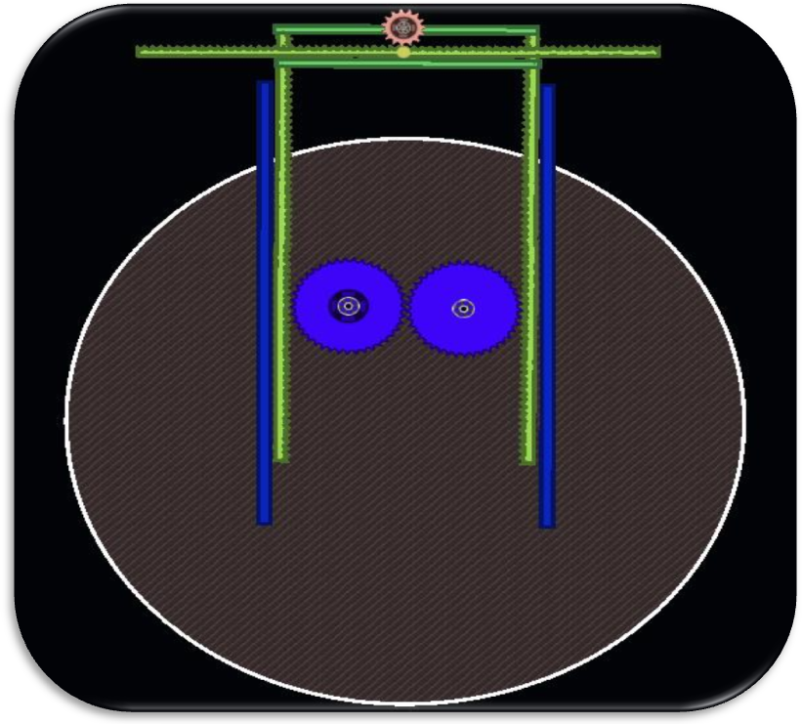
A third servo motor will be attached to the pen through a connector to lift it when not required.
Rack and Pinion arrangement

Software Interfaces

We will be programming our robot using embedded C coding using AVR editor software.
The codes will be sent to the robot using wireless ZigBee module using the FireBird GUI. We will also be making a GUI for user to input the character which will be sent to the robot.
Codes already available for wireless communication with ZigBee module will be used with some modifications from e-yantra website.
To reduce testing and debugging time we will try to using Microsoft Robotics Studio.

Communications Interfaces

We will be using ZigBee wireless standard for communication between robot and computer. All the character information will be stored in computer and processing will be done by the computer only.
As ZigBee uses UART method there is no need for a common clock for data synchronization.
When user gives an input in the computer for writing a character, the computer processes it and finds the coordinates stored in the library of the character and then all the line coordinates of the character is sent from computer to robot though ZigBee. The robot follows the coordinates and writes the character.
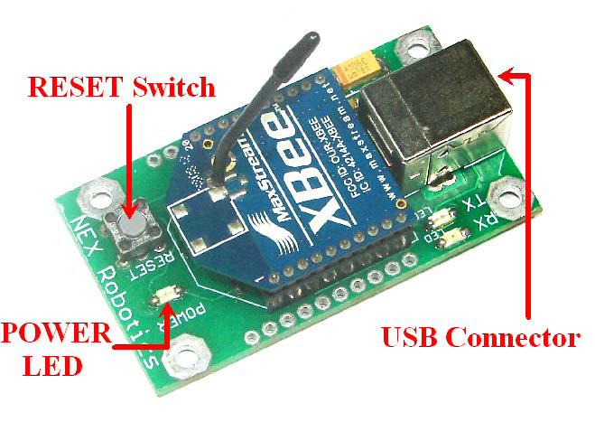

Quality Control

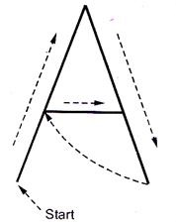
Our robot will be programmed to write Standard English characters with the help of pen on a paper under it. The characters will be written by straight lines, so writing for characters like A,E,F,H,etc will be written very precisely.

But for the characters which require curves like C,D,G,P,etc the motors will be varied in such a way that it draws a curve from straight lines. Although the curves will not be very precise but will certainly look like a curved character.

The factors like rack and pinion arrangement and motors acceleration might affect the process and so we will be making the robot write larger fonts, which will make error look smaller.

To make the robot write precisely we will be testing all our algorithms and codes in virtual environment using Microsoft Robotics Studio.

Risk Management

Being in final year of engineering we have learnt all sort of theory subjects but when it comes to real execution of a project, there may arise many uncertain problems and risks.

The biggest risk is that, this is the first time an inter-departmental project is being done in Mumbai University. But with full support of our Principal we are very positive towards the project.

Following are the technical risks that we might be facing while completing the project :

- The ATMEGA2560 platform that we are using will need a detailed study of all its manuals.
- As the gripper available in the market is too heavy for our robot to be stable, we will be designing and making our own mechanism for moving the pen and writing different characters.
- We have never used ZigBee module before, so we will be studying it in detail.
- The STROKE method we are planning to use can only write straight lines, so making curves with the mechanism is a challenge.
- We will be trying to first test the codes in Microsoft Robotics Studio, so learning how to use the software is a challenge.

